### Confusion matrices and statistical metrics for parameter assessment (TRAINING: 2.7m/0 deg)

**Sunny conditions**

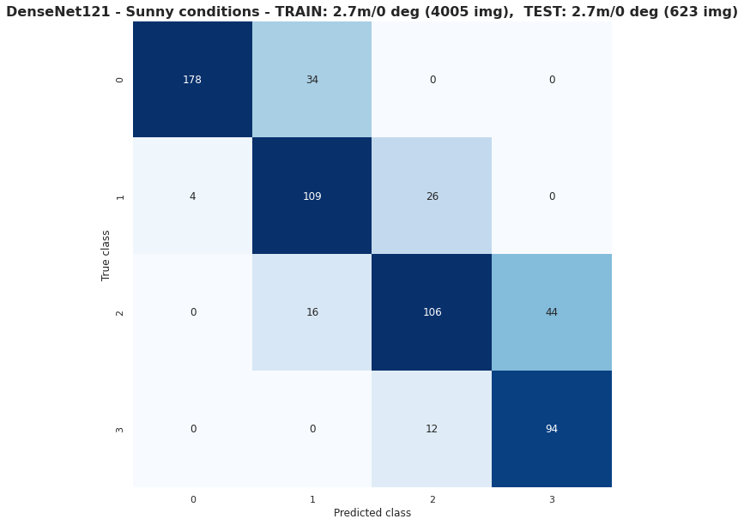

|  |  |  |  |
| --- | --- | --- | --- |
|  | Precision | Recall | F1-score |
| Class 0 | 0.98 | 0.84 | 0.90 |
| Class 1 | 0.69 | 0.78 | 0.73 |
| Class 2 | 0.74 | 0.64 | 0.68 |
| Class 3 | 0.68 | 0.89 | 0.77 |
|  | | | |
| Accuracy |  |  | 0.78 |
| Macro Average | 0.77 | 0.79 | 0.77 |
| Weighted Average | 0.80 | 0.78 | 0.78 |

**Cloudy conditions**

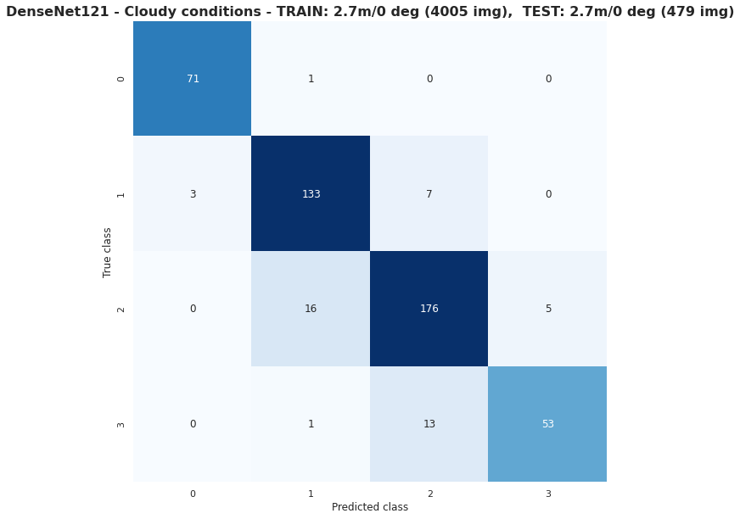

|  |  |  |  |
| --- | --- | --- | --- |
|  | Precision | Recall | F1-score |
| Class 0 | 0.96 | 0.99 | 0.97 |
| Class 1 | 0.88 | 0.93 | 0.90 |
| Class 2 | 0.90 | 0.89 | 0.90 |
| Class 3 | 0.91 | 0.79 | 0.85 |
|  | | | |
| Accuracy |  |  | 0.90 |
| Macro Average | 0.91 | 0.90 | 0.91 |
| Weighted Average | 0.90 | 0.90 | 0.90 |

**2.7m/45 deg**

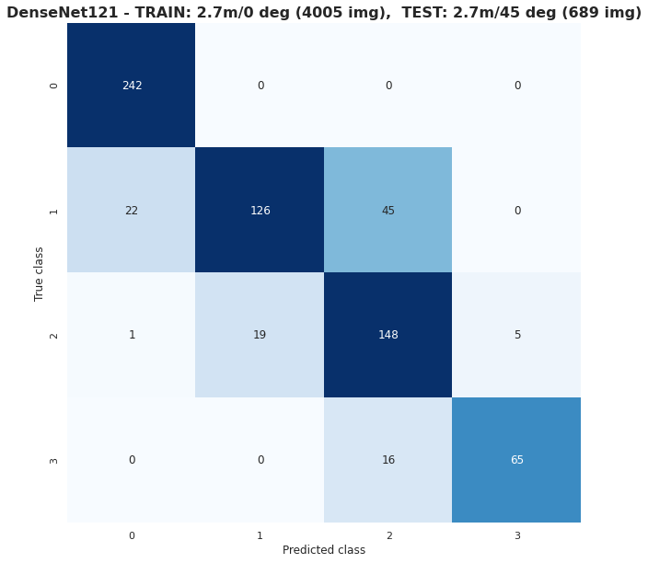

|  |  |  |  |
| --- | --- | --- | --- |
|  | Precision | Recall | F1-score |
| Class 0 | 0.91 | 1.00 | 0.95 |
| Class 1 | 0.87 | 0.65 | 0.75 |
| Class 2 | 0.71 | 0.86 | 0.77 |
| Class 3 | 0.93 | 0.80 | 0.86 |
|  | | | |
| Accuracy |  |  | 0.84 |
| Macro Average | 0.85 | 0.83 | 0.83 |
| Weighted Average | 0.85 | 0.84 | 0.84 |

**4.0m/0 deg**

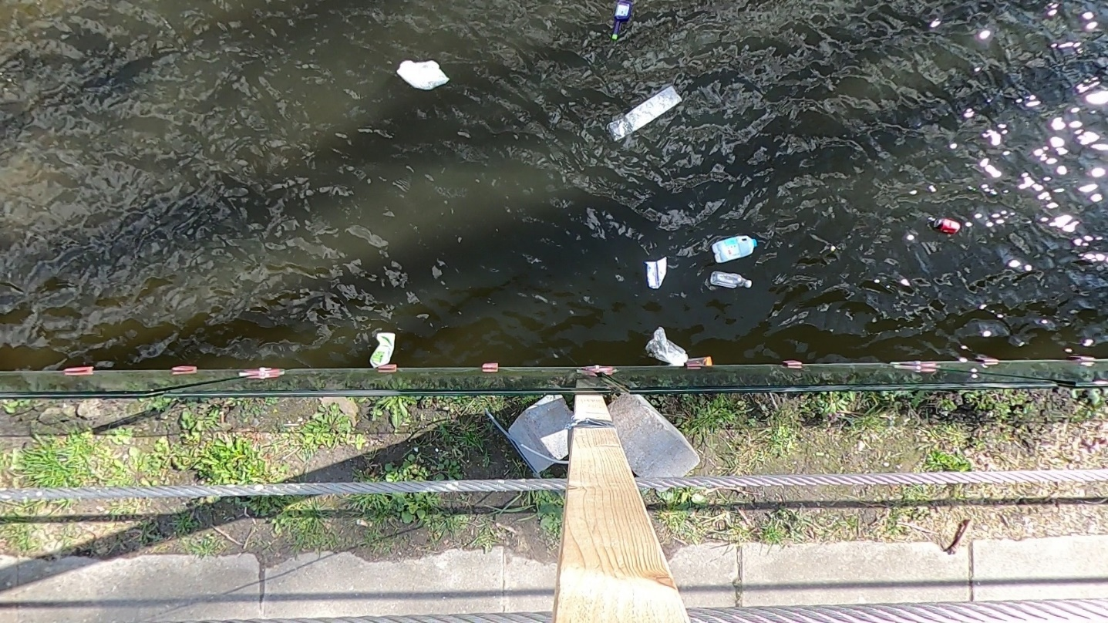

**UNCROPPED**

**CROPPED**

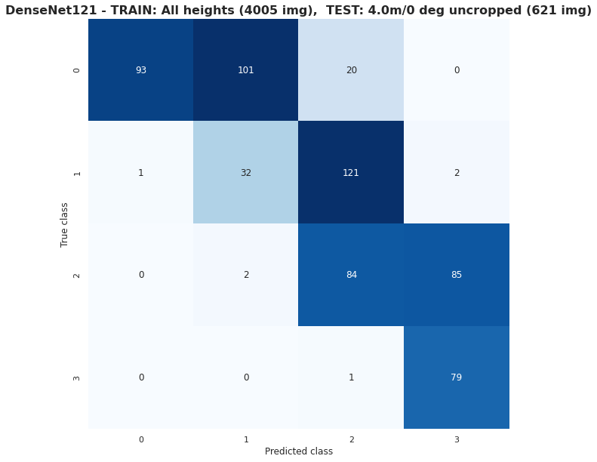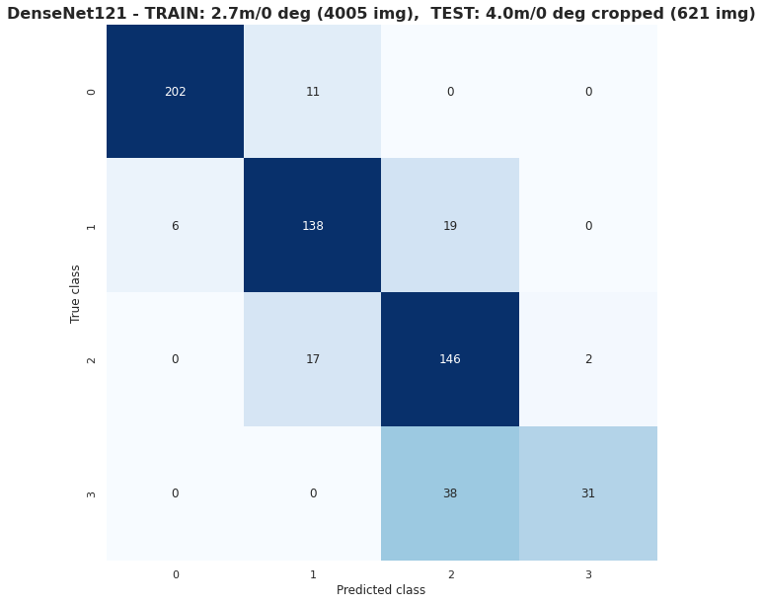

|  |  |  |  |
| --- | --- | --- | --- |
|  | Precision | Recall | F1-score |
| Class 0 | 0.99 | 0.43 | 0.60 |
| Class 1 | 0.24 | 0.21 | 0.22 |
| Class 2 | 0.37 | 0.49 | 0.42 |
| Class 3 | 0.48 | 0.99 | 0.64 |
|  | | | |
| Accuracy |  |  | 0.46 |
| Macro Average | 0.52 | 0.53 | 0.47 |
| Weighted Average | 0.56 | 0.46 | 0.46 |



|  |  |  |  |
| --- | --- | --- | --- |
|  | Precision | Recall | F1-score |
| Class 0 | 0.97 | 0.95 | 0.96 |
| Class 1 | 0.83 | 0.85 | 0.84 |
| Class 2 | 0.72 | 0.88 | 0.79 |
| Class 3 | 0.94 | 0.45 | 0.61 |
|  | | | |
| Accuracy |  |  | 0.85 |
| Macro Average | 0.87 | 0.78 | 0.80 |
| Weighted Average | 0.86 | 0.85 | 0.84 |

**4.0m/45 deg**

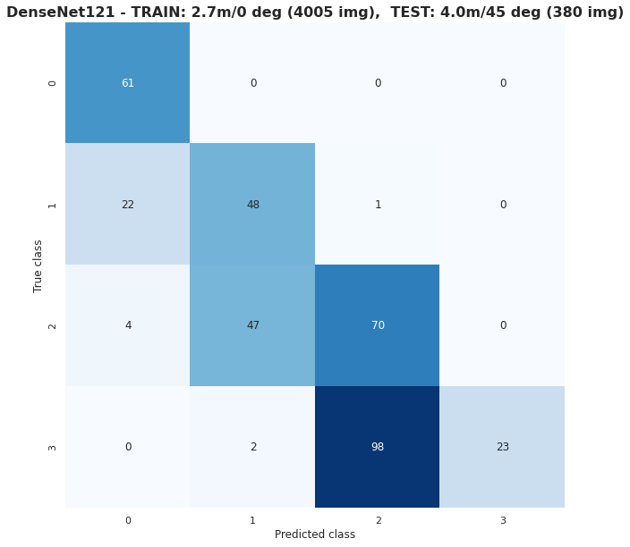

|  |  |  |  |
| --- | --- | --- | --- |
|  | Precision | Recall | F1-score |
| Class 0 | 0.70 | 1.00 | 0.82 |
| Class 1 | 0.49 | 0.68 | 0.57 |
| Class 2 | 0.41 | 0.58 | 0.48 |
| Class 3 | 1.00 | 0.19 | 0.32 |
|  | | | |
| Accuracy |  |  | 0.54 |
| Macro Average | 0.65 | 0.61 | 0.55 |
| Weighted Average | 0.67 | 0.54 | 0.50 |

### Confusion matrices and statistical metrics for parameter assessment (TRAINING: All heights + angles)

**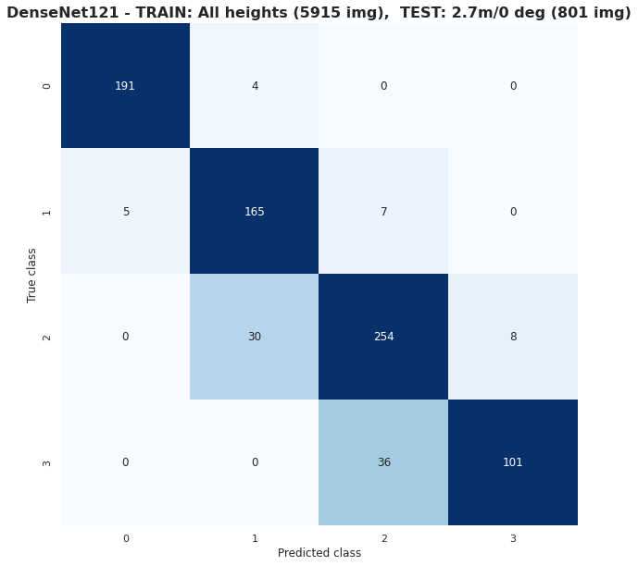  
2.7m/0 deg**

|  |  |  |  |
| --- | --- | --- | --- |
|  | Precision | Recall | F1-score |
| Class 0 | 0.97 | 0.98 | 0.98 |
| Class 1 | 0.83 | 0.93 | 0.88 |
| Class 2 | 0.86 | 0.87 | 0.86 |
| Class 3 | 0.93 | 0.74 | 0.82 |
|  | | | |
| Accuracy |  |  | 0.89 |
| Macro Average | 0.90 | 0.88 | 0.88 |
| Weighted Average | 0.89 | 0.89 | 0.89 |

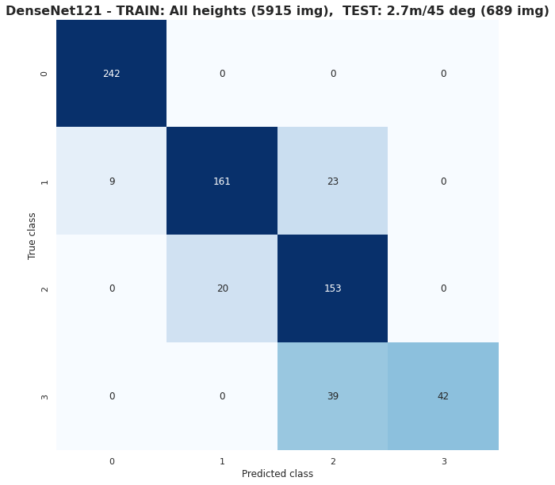**2.7m/45 deg**

|  |  |  |  |
| --- | --- | --- | --- |
|  | Precision | Recall | F1-score |
| Class 0 | 0.96 | 1.00 | 0.98 |
| Class 1 | 0.89 | 0.83 | 0.86 |
| Class 2 | 0.71 | 0.88 | 0.79 |
| Class 3 | 1.00 | 0.52 | 0.68 |
|  | | | |
| Accuracy |  |  | 0.87 |
| Macro Average | 0.89 | 0.81 | 0.83 |
| Weighted Average | 0.88 | 0.87 | 0.86 |

**4.0m/0 deg**

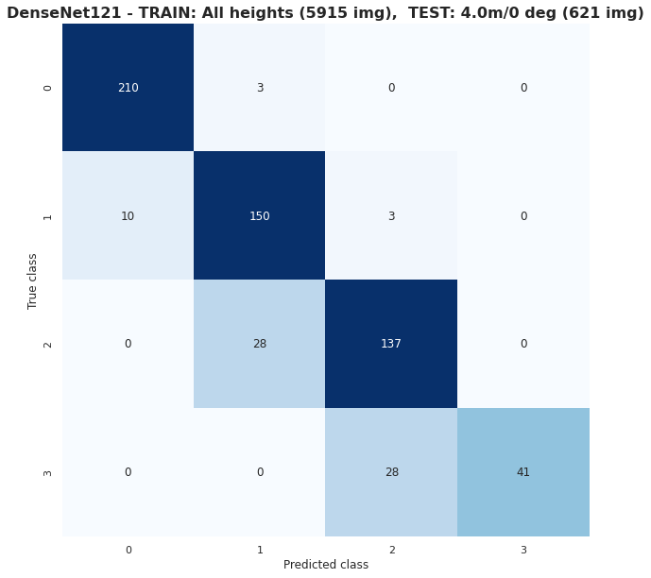

|  |  |  |  |
| --- | --- | --- | --- |
|  | Precision | Recall | F1-score |
| Class 0 | 0.95 | 0.99 | 0.97 |
| Class 1 | 0.83 | 0.92 | 0.87 |
| Class 2 | 0.82 | 0.83 | 0.82 |
| Class 3 | 1.00 | 0.59 | 0.75 |
|  | | | |
| Accuracy |  |  | 0.88 |
| Macro Average | 0.90 | 0.83 | 0.85 |
| Weighted Average | 0.89 | 0.88 | 0.88 |

**4.0m/45 deg**

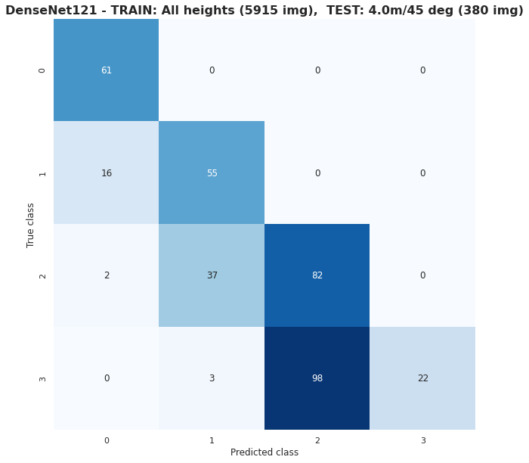

|  |  |  |  |
| --- | --- | --- | --- |
|  | Precision | Recall | F1-score |
| Class 0 | 0.77 | 1.00 | 0.87 |
| Class 1 | 0.58 | 0.77 | 0.66 |
| Class 2 | 0.46 | 0.68 | 0.54 |
| Class 3 | 1.00 | 0.18 | 0.30 |
|  | | | |
| Accuracy |  |  | 0.59 |
| Macro Average | 0.70 | 0.66 | 0.60 |
| Weighted Average | 0.71 | 0.59 | 0.54 |